**DIGITAL BUSINESS CARD**

# **Submitted by:**

# ***Team Members****- Anushka Pravakar , Krupa Anna Chandy ,Shrayana KS*

***Roll Number****- 2462045 , 2462104 , 2462149*

***College****-* [*anushka.pravakar@btech.christuniversity.in*](mailto:anushka.pravakar@btech.christuniversity.in)

[*krupa.anna@btech.christuniversity.in*](mailto:krupa.anna@btech.christuniversity.in)

[*shrayana.k@btech.christuniversity.in*](mailto:shrayana.k@btech.christuniversity.in)

***Course****: UI/UX Design Fundamentals*

***Instructor Name****: Nagaveena*

***Institution****: Christ University Kengeri Campus*

*·****Date of Submission****: 13/08/2025*

**ABSTRACT**

The Digital Business Card project is a modern web-based application designed using HTML and CSS to replace traditional paper business cards with an interactive and visually appealing digital format. This project allows users to present their professional identity, contact information, and social media profiles in a single, compact, and easily shareable interface. The digital card includes key details such as name, designation, company, phone number, email, website, and links to professional or social networking platforms.

The project emphasizes responsive design principles, ensuring that the card is accessible and visually consistent across various devices, including desktops, tablets, and smartphones. By implementing structured HTML for content and CSS for styling, the project demonstrates core front-end development skills, including layout management, typography, color schemes, and user interface design.

In addition to providing a professional and modern representation of contact information, the digital business card enhances user convenience by enabling quick updates and easy sharing through digital platforms. The project also reflects eco-friendly practices by reducing paper usage while maintaining professional networking standards. Overall, this project strengthens practical skills in web development, promotes user-centric design, and offers a cost-effective, sustainable solution for personal and professional branding.

**OBJECTIVES**

1. **Create a Digital Alternative to Traditional Cards:** Develop a web-based business card to replace paper cards, making it easier to share contact information digitally.
2. **Display Professional Information Clearly:** Include essential details such as name, designation, company, phone number, email, website, and social media profiles in an organized format.
3. **Implement Responsive Design:** Ensure the card is accessible and visually appealing across multiple devices, including desktops, tablets, and smartphones.
4. **Enhance User Experience:** Use HTML and CSS to design an attractive, user-friendly layout with proper typography, colors, and spacing.
5. **Enable Easy Updates and Sharing:** Allow users to quickly update their information and share the card through digital channels like email or messaging apps.
6. **Promote Eco-Friendly Practices:** Reduce the need for paper-based business cards, supporting sustainable and cost-effective professional networking.
7. **Strengthen Front-End Development Skills:** Provide practical experience in HTML structuring, CSS styling, and UI design principles.
8. **Demonstrate Professional Branding:** Help users create a visually consistent and modern digital identity to enhance their personal or corporate branding.

**SCOPE OF THE PROJECT**

The Digital Business Card project aims to provide a modern, interactive, and easily shareable alternative to traditional paper business cards. Its scope includes the following aspects:

1. **Digital Accessibility:**  
    The project allows users to access their business card from any device with a web browser, eliminating the need for physical cards.
2. **Comprehensive Contact Information:**  
    Users can showcase essential professional details such as name, designation, company, phone number, email, website, and social media links in one place.
3. **Responsive Design:**  
    The digital card is designed to adapt seamlessly to various screen sizes and devices, ensuring a consistent user experience on desktops, tablets, and smartphones.
4. **Customization and Updates:**  
    Users can easily update their information or modify the appearance of the card without incurring extra costs, unlike printing new paper cards.
5. **Professional Networking:**  
    The card can be shared digitally through email, messaging apps, QR codes, or websites, facilitating networking in both personal and professional contexts.
6. **Eco-Friendly Solution:**  
    By reducing reliance on paper cards, the project promotes sustainability and cost-effectiveness.
7. **Skill Demonstration:**  
    The project serves as a practical showcase of front-end web development skills, including HTML structuring, CSS styling, and UI/UX design principles.
8. **Future Expansion:**  
    The project can be extended to include interactive features such as downloadable vCards, animated effects, or integration with portfolio websites and LinkedIn profile.

**TOOLS & TECHNOLOGIES USED**

1- **HTML (HyperText Markup Language):**

* Used to structure the content of the digital business card.
* Elements like headings, paragraphs, lists, links, and images are created using HTML.
* Provides the semantic foundation for a well-organized webpage.

2- **CSS (Cascading Style Sheets):**

* Used to style and visually enhance the digital card.
* Controls layout, typography, colors, backgrounds, spacing, and responsiveness.
* Allows the creation of interactive effects such as hover animations.

3- **Responsive Design Techniques:**

* Ensures the business card is viewable and functional across devices of various screen sizes (desktops, tablets, smartphones).
* Media queries in CSS are used to adjust layout and styling for different devices.

4- **Web Browsers:**

* The card is designed to be compatible with modern browsers like Chrome, Edge, Firefox, and Safari

**KEY FEATURES**

1- **Professional Information Display:**

* Shows essential details such as name, designation, company, phone number, email, website, and social media links in a clean and organized layout.

2- **Responsive Design:**

* Automatically adjusts to different screen sizes, ensuring optimal viewing on desktops, tablets, and smartphones.

3- **Interactive Elements:**

* Includes clickable links for email, phone number, and social media profiles for easy access.
* Hover effects on buttons or sections enhance user experience.

4- **Easy Updates:**

* Users can quickly modify their information or styling without needing to print new cards.

5- **Eco-Friendly and Cost-Effective:**

* Eliminates the need for physical paper cards, supporting sustainability and reducing costs.

6- **Attractive Layout and Styling:**

* Uses HTML and CSS to create a visually appealing interface with proper typography, colors, spacing, and design consistency.

7- **Shareable:**

* Can be shared digitally through links, emails, messaging apps, or QR codes.

8- **Scalable for Future Enhancements:**

* Can be extended to include features like downloadable vCards, animated effects, or portfolio integration.

9- **User-Centric Design:**

* Focuses on clarity, readability, and ease of navigation, providing a smooth experience for both the card owner and recipients.

**CHALLENGES FACED AND SOLUTION**

1. Challenge: Creating a responsive design that works well on all devices (desktop, tablet, mobile).  
    Solution: Used CSS media queries and flexible layouts with relative units (like percentages and em) to ensure the card adapts to different screen sizes.
2. Challenge: Making the card visually appealing while keeping it simple and professional.  
    Solution: Applied consistent color schemes, readable fonts from Google Fonts, and proper spacing using CSS to maintain clarity and aesthetic appeal.
3. Challenge: Ensuring that all links (email, phone, social media) are functional and easy to access.  
    Solution: Added clickable HTML anchor tags with mailto: for email and proper URLs for social media, tested across multiple browsers to ensure compatibility.
4. Challenge: Avoiding clutter while displaying multiple pieces of information on a small card layout.  
    Solution: Structured content using sections and divs in HTML, and used CSS flexbox/grid layouts to organize information cleanly.
5. Challenge: Limited interactivity using only HTML and CSS.  
    Solution: Implemented hover effects, tooltips, and visual cues in CSS to provide a sense of interactivity without JavaScript.
6. Challenge: Maintaining fast loading time and lightweight design.  
    Solution: Optimized images, minimized CSS code, and avoided unnecessary scripts to ensure the card loads quickly even on slower internet connections**.**

**OUTCOME**

The Digital Business Card project successfully achieved its objective of creating a modern, interactive, and eco-friendly alternative to traditional paper business cards. Using HTML and CSS, the project delivered a responsive, visually appealing, and professional card layout that can be accessed and shared across multiple devices. The card effectively displays essential personal and professional details, with clickable links for direct communication and networking.

The final product is lightweight, fast-loading, and easy to maintain, allowing for quick updates without reprinting costs. It demonstrates practical front-end development skills, including content structuring, responsive design, and user interface styling. The project also promotes sustainable practices by eliminating the need for physical cards.

Overall, the project provides a functional and aesthetically pleasing tool for digital networking, with potential for future enhancements such as interactive animations, downloadable vCards, or portfolio integration.

**FUTURE ENHANCEMENT**

1- **QR Code Integration:**

* Add a QR code that, when scanned, opens the digital business card directly on any device.

2- **Downloadable vCard Feature:**

* Allow users to download the contact details in .vcf format for quick saving to phone or email contact lists.

3- **Portfolio and Resume Integration:**

* Link the card to an online portfolio, resume, or LinkedIn profile for showcasing professional work.

4- **JavaScript Interactivity:**

* Add animations, pop-ups, and transitions to enhance user engagement.

5- **Multi-Language Support:**

* Offer content in different languages for a global audience.

# **SAMPLE CODE AND SCREENSHOT OF FINAL OUTPUT**

**HTML**

<!DOCTYPE html>

<html lang="en">

<head>

<meta charset="UTF-8">

<meta name="viewport" content="width=device-width, initial-scale=1.0">

<title>Clarissa Fray - Digital Business Card</title>

<link rel="preconnect" href="https://fonts.googleapis.com">

<link rel="preconnect" href="https://fonts.gstatic.com" crossorigin>

<link href="https://fonts.googleapis.com/css2?family=Orbitron:wght@600&family=Roboto:wght@300;400;500&display=swap" rel="stylesheet">

<link rel="stylesheet" href="businesscard.css">

</head>

<body>

<main class="card-container">

<div class="business-card">

<div class="profile-section">

<div class="profile-wrapper">

<div class="profile-ring"></div>

<img src="https://imgcdn.stablediffusionweb.com/2024/12/3/80f18dc7-e45d-43fa-81b2-3048e4672cea.jpg" alt="Your Profile Picture" class="profile-photo">

</div>

<h1 class="card-name">Clarissa Fray</h1>

<h2 class="card-title"><b>Chief Financial Officer [CFO]</b></h2>

<p class="card-bio">

Strategic Architect of Financial Growth<br><br>

<strong>Expertise</strong><br>

• Financial Strategy & Planning<br>

• Capital Structuring & Fundraising<br>

• Risk Management & Compliance<br>

• Digital Finance Transformation<br>

• M&A & Growth Leadership<br><br>

<strong>Vision</strong><br>

Empowering agile finance teams to drive innovation, resilience, and data-informed transformation.

</p>

</div>

<div class="links-section">

<a href="mailto:youremail@example.com" class="link-button">Email</a>

<a href="https://www.linkedin.com/in/yourprofile" target="_blank" class="link-button">LinkedIn</a>

<a href="https://yourportfolio.com" target="_blank" class="link-button">Portfolio</a>

</div>

</div>

<footer class="card-footer">

<p>&copy; <span id="current-year"></span> Clarissa Fray. All Rights Reserved.</p>

</footer>

</main>

<script>

document.getElementById('current-year').textContent = new Date().getFullYear();

</script>

</body>

</html>

**CSS**

/* Global Styles */

body {

margin: 0;

font-family: 'Roboto', sans-serif;

background-color: #121212;

color: #e0e0e0;

display: flex;

justify-content: center;

align-items: center;

min-height: 100vh;

}

@keyframes pulse {

0% {

transform: scale(1);

opacity: 0.8;

}

50% {

transform: scale(1.1);

opacity: 1;

}

100% {

transform: scale(1);

opacity: 0.8;

}

}

.card-container {

display: flex;

flex-direction: column;

align-items: center;

justify-content: center;

padding: 20px;

}

.business-card {

background-color: #1e1e1e;

border: 1px solid #333;

border-radius: 20px;

box-shadow: 0 10px 40px rgba(0, 255, 255, 0.2);

padding: 40px;

width: 90%;

max-width: 400px;

text-align: center;

position: relative;

overflow: hidden;

transition: transform 0.4s ease;

}

.business-card:hover {

transform: translateY(-5px);

}

.profile-section {

margin-bottom: 30px;

}

.profile-wrapper {

position: relative;

width: 140px;

height: 140px;

margin: 0 auto 20px;

}

.profile-ring {

position: absolute;

top: 0;

left: 0;

width: 140px;

height: 140px;

border-radius: 50%;

border: 3px solid #00ffff;

box-shadow: 0 0 15px #00ffff, inset 0 0 15px #00ffff;

animation: pulse 2s infinite ease-in-out;

z-index: 1;

}

.profile-photo {

position: absolute;

top: 10px;

left: 10px;

width: 120px;

height: 120px;

border-radius: 50%;

border: 4px solid #1e1e1e;

object-fit: cover;

transition: transform 0.3s ease;

z-index: 2;

}

.profile-photo:hover {

transform: rotate(5deg);

}

.card-name {

font-family: 'Orbitron', sans-serif;

font-size: 2.2rem;

color: #00ffff;

text-transform: uppercase;

letter-spacing: 2px;

margin: 0;

}

.card-title {

font-size: 1rem;

margin: 5px 0 20px;

font-weight: 400;

color: #b0b0b0;

}

.card-bio {

font-size: 0.9rem;

color: #a0a0a0;

line-height: 1.6;

}

.links-section {

margin-top: 30px;

display: flex;

flex-direction: column;

gap: 15px;

}

.link-button {

text-decoration: none;

font-weight: 500;

padding: 15px;

border-radius: 50px;

color: #121212;

background-color: #00ffff;

transition: transform 0.3s ease, background-color 0.3s ease, box-shadow 0.3s ease;

box-shadow: 0 5px 15px rgba(0, 255, 255, 0.3);

}

.link-button:hover {

background-color: #00e5e5;

transform: translateY(-3px);

box-shadow: 0 8px 20px rgba(0, 255, 255, 0.5);

}

.card-footer {

margin-top: 30px;

font-size: 0.8rem;

color: #555;

}

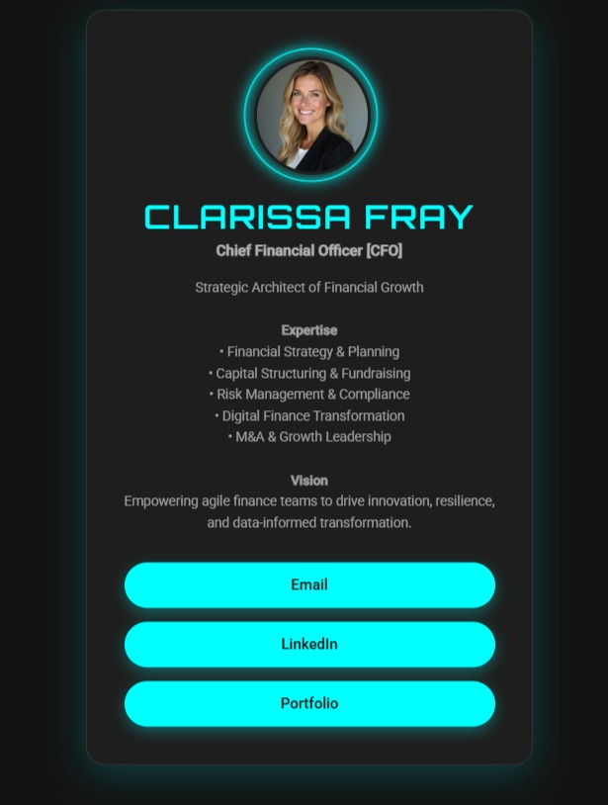

**CONCLUSION**

The Digital Business Card project successfully demonstrates how traditional paper-based contact sharing can be transformed into a modern, eco-friendly, and highly accessible digital solution. Developed using HTML and CSS, the project delivers a clean, responsive, and professional interface that effectively presents essential personal and professional details. Its design ensures compatibility across multiple devices, while clickable links provide seamless communication and networking opportunities.

Through this project, core front-end development skills were applied, including content structuring, responsive layout creation, and user interface styling. The outcome not only meets the project’s objectives but also reflects the potential for future enhancements, such as QR code integration, downloadable vCards, and portfolio linking.

In conclusion, the Digital Business Card offers a cost-effective, sustainable, and user-friendly alternative to printed cards, aligning with the needs of modern professionals and supporting environmentally conscious practices.

**REFERENCES**

* L&T LMS:<https://learn.lntedutech.com/Landing/MyCourse>